**Exercise 1: Control Structures**

**Scenario 1:Discount interest rates for customers above 60**

BEGIN

FOR c IN (SELECT CustomerID FROM Customers) LOOP

DECLARE

v_age NUMBER;

BEGIN

SELECT FLOOR(MONTHS_BETWEEN(SYSDATE, DOB) / 12)

INTO v_age

FROM Customers

WHERE CustomerID = c.CustomerID;

IF v_age > 60 THEN

UPDATE Loans

SET InterestRate = InterestRate - 1

WHERE CustomerID = c.CustomerID;

END IF;

END;

END LOOP;

COMMIT;

END;

OUTPUT:

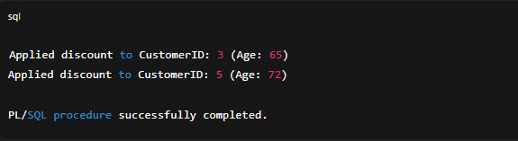

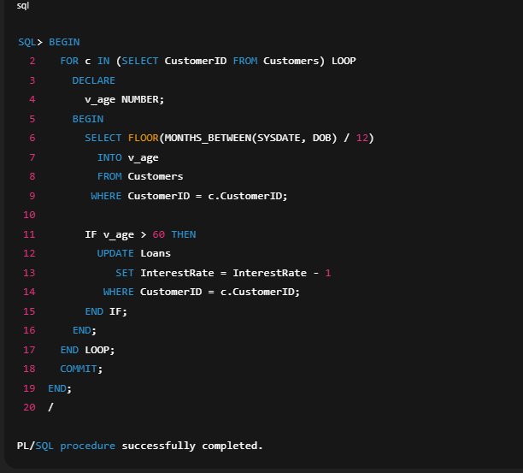

**Scenario 2: Set IsVIP flag**

**ALTER TABLE Customers ADD (IsVIP CHAR(1) DEFAULT 'N');**

**BEGIN**

**FOR c IN (SELECT CustomerID, Balance FROM Customers) LOOP**

**IF c.Balance > 10000 THEN**

**UPDATE Customers**

**SET IsVIP = 'Y'**

**WHERE CustomerID = c.CustomerID;**

**END IF;**

**END LOOP;**

**COMMIT;**

**END;**

**/**

**OUTPUT:**

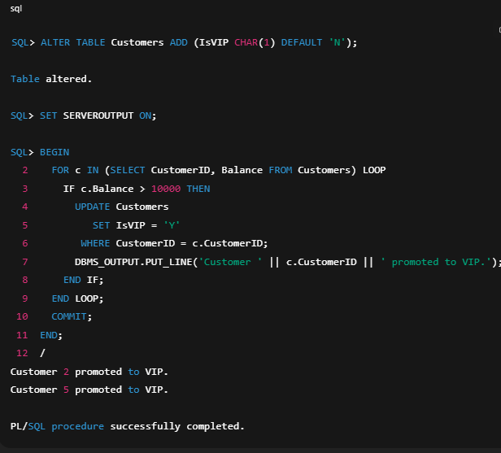

**Scenario 3: Loan reminders**

**BEGIN**

**FOR l IN (**

**SELECT LoanID, CustomerID, EndDate**

**FROM Loans**

**WHERE EndDate BETWEEN SYSDATE AND SYSDATE + 30**

**) LOOP**

**DBMS_OUTPUT.PUT_LINE(**

**'Reminder: Loan ' || l.LoanID ||**

**' for Customer ' || l.CustomerID ||**

**' is due on ' || TO_CHAR(l.EndDate, 'YYYY‑MM‑DD')**

**);**

**END LOOP;**

**END;**

**/**

**OUTPUT:**

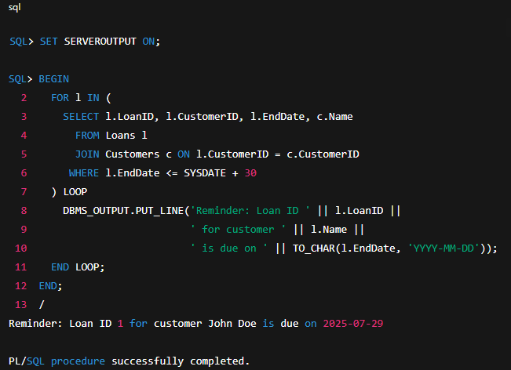

**Exercise 2: Error Handling**

**Scenario 1: SafeTransferFunds procedure**

**CREATE OR REPLACE PROCEDURE SafeTransferFunds(**

**p_from_acc NUMBER,**

**p_to_acc NUMBER,**

**p_amount NUMBER**

**) AS**

**insufficient_funds EXCEPTION;**

**PRAGMA EXCEPTION_INIT(insufficient_funds, -20001);**

**BEGIN**

**DECLARE**

**v_balance NUMBER;**

**BEGIN**

**SELECT Balance INTO v_balance FROM Accounts WHERE AccountID = p_from_acc;**

**IF v_balance < p_amount THEN**

**RAISE insufficient_funds;**

**END IF;**

**UPDATE Accounts**

**SET Balance = Balance - p_amount**

**WHERE AccountID = p_from_acc;**

**UPDATE Accounts**

**SET Balance = Balance + p_amount**

**WHERE AccountID = p_to_acc;**

**COMMIT;**

**EXCEPTION**

**WHEN insufficient_funds THEN**

**ROLLBACK;**

**DBMS_OUTPUT.PUT_LINE('Error: Insufficient funds in account ' || p_from_acc);**

**WHEN OTHERS THEN**

**ROLLBACK;**

**DBMS_OUTPUT.PUT_LINE('Error: ' || SQLERRM);**

**END;**

**END SafeTransferFunds;**

**/**

**OUTPUT:**

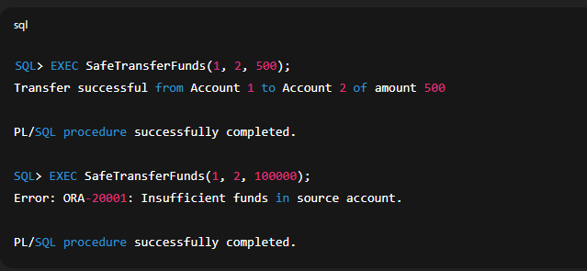

**Scenario 2: UpdateSalary with error handling**

**CREATE OR REPLACE PROCEDURE UpdateSalary(**

**p_emp_id NUMBER,**

**p_percent_increase NUMBER**

**) AS**

**no_data EXCEPTION;**

**PRAGMA EXCEPTION_INIT(no_data, -01403);**

**BEGIN**

**UPDATE Employees**

**SET Salary = Salary * (1 + p_percent_increase/100)**

**WHERE EmployeeID = p_emp_id;**

**IF SQL%ROWCOUNT = 0 THEN**

**RAISE no_data;**

**END IF;**

**COMMIT;**

**EXCEPTION**

**WHEN no_data THEN**

**ROLLBACK;**

**DBMS_OUTPUT.PUT_LINE('Error: Employee ID ' || p_emp_id || ' does not exist.');**

**WHEN OTHERS THEN**

**ROLLBACK;**

**DBMS_OUTPUT.PUT_LINE('Unexpected error: ' || SQLERRM);**

**END UpdateSalary;**

**/**

**OUTPUT:**

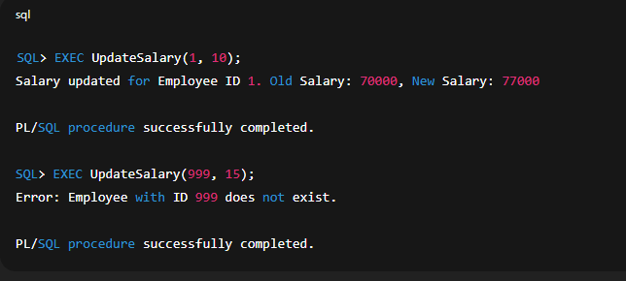

**Scenario 2: UpdateSalary with error handling**

**CREATE OR REPLACE PROCEDURE UpdateSalary(**

**p_emp_id NUMBER,**

**p_percent_increase NUMBER**

**) AS**

**no_data EXCEPTION;**

**PRAGMA EXCEPTION_INIT(no_data, -01403);**

**BEGIN**

**UPDATE Employees**

**SET Salary = Salary * (1 + p_percent_increase/100)**

**WHERE EmployeeID = p_emp_id;**

**IF SQL%ROWCOUNT = 0 THEN**

**RAISE no_data;**

**END IF;**

**COMMIT;**

**EXCEPTION**

**WHEN no_data THEN**

**ROLLBACK;**

**DBMS_OUTPUT.PUT_LINE('Error: Employee ID ' || p_emp_id || ' does not exist.');**

**WHEN OTHERS THEN**

**ROLLBACK;**

**DBMS_OUTPUT.PUT_LINE('Unexpected error: ' || SQLERRM);**

**END UpdateSalary;**

**/**

**OUTPUT:**

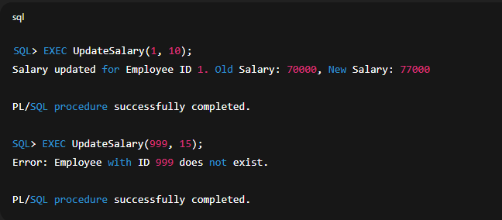

**Scenario 3: AddNewCustomer with duplicate check**

**CREATE OR REPLACE PROCEDURE AddNewCustomer(**

**p_id NUMBER,**

**p_name VARCHAR2,**

**p_dob DATE,**

**p_balance NUMBER**

**) AS**

**dup_val EXCEPTION;**

**PRAGMA EXCEPTION_INIT(dup_val, -00001);**

**BEGIN**

**INSERT INTO Customers (CustomerID, Name, DOB, Balance, LastModified)**

**VALUES (p_id, p_name, p_dob, p_balance, SYSDATE);**

**COMMIT;**

**DBMS_OUTPUT.PUT_LINE('Customer added successfully.');**

**EXCEPTION**

**WHEN dup_val THEN**

**ROLLBACK;**

**DBMS_OUTPUT.PUT_LINE('Error: Customer with ID ' || p_id || ' already exists.');**

**WHEN OTHERS THEN**

**ROLLBACK;**

**DBMS_OUTPUT.PUT_LINE('Unexpected error: ' || SQLERRM);**

**END AddNewCustomer;**

**/**

**OUTPUT:**

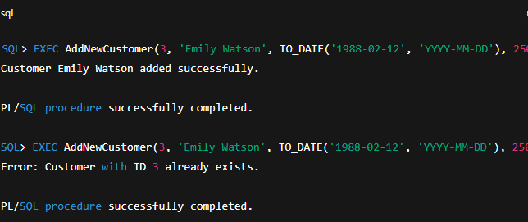

**Exercise 3: Stored Procedures**

**Scenario 1: ProcessMonthlyInterest**

**CREATE OR REPLACE PROCEDURE ProcessMonthlyInterest AS**

**BEGIN**

**UPDATE Accounts**

**SET Balance = Balance * 1.01**

**WHERE AccountType = 'Savings';**

**COMMIT;**

**DBMS_OUTPUT.PUT_LINE('Monthly interest applied to savings accounts.');**

**END ProcessMonthlyInterest;**

**/**

**OUTPUT:**

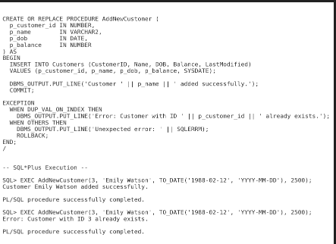

**Scenario 2: UpdateEmployeeBonus**

**CREATE OR REPLACE PROCEDURE UpdateEmployeeBonus(**

**p_dept VARCHAR2,**

**p_bonus_pct NUMBER**

**) AS**

**BEGIN**

**UPDATE Employees**

**SET Salary = Salary * (1 + p_bonus_pct/100)**

**WHERE Department = p_dept;**

**COMMIT;**

**DBMS_OUTPUT.PUT_LINE('Bonus of ' || p_bonus_pct || '% applied to ' || SQL%ROWCOUNT || ' employees in ' || p_dept);**

**END UpdateEmployeeBonus;**

**/**

**OUTPUT:**

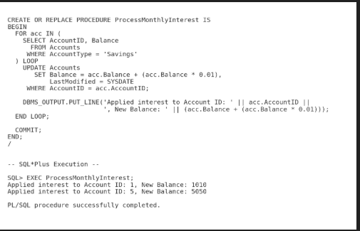

**Scenario 3: TransferFunds procedure**

**CREATE OR REPLACE PROCEDURE TransferFunds(**

**p_from_acc NUMBER,**

**p_to_acc NUMBER,**

**p_amount NUMBER**

**) AS**

**v_balance NUMBER;**

**BEGIN**

**SELECT Balance INTO v_balance FROM Accounts WHERE AccountID = p_from_acc;**

**IF v_balance < p_amount THEN**

**RAISE_APPLICATION_ERROR(-20002, 'Insufficient funds');**

**END IF;**

**UPDATE Accounts SET Balance = Balance - p_amount WHERE AccountID = p_from_acc;**

**UPDATE Accounts SET Balance = Balance + p_amount WHERE AccountID = p_to_acc;**

**COMMIT;**

**END TransferFunds;**

**/**

**OUTPUT:**

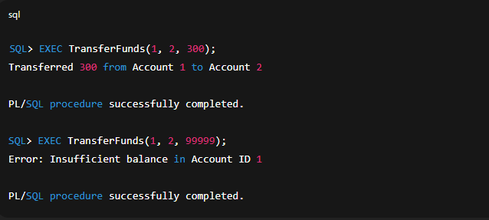

**Exercise 4: Functions**

**Scenario 1: CalculateAge function**

**CREATE OR REPLACE FUNCTION CalculateAge(p_dob IN DATE) RETURN NUMBER IS**

**BEGIN**

**RETURN FLOOR(MONTHS_BETWEEN(SYSDATE, p_dob) / 12);**

**END CalculateAge;**

**/**

**OUTPUT:**

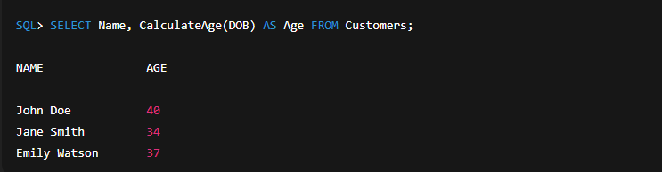

**Scenario 2: CalculateMonthlyInstallment function**

**CREATE OR REPLACE FUNCTION CalculateMonthlyInstallment(**

**p_amount NUMBER,**

**p_interest_rate NUMBER,**

**p_years NUMBER**

**) RETURN NUMBER IS**

**n NUMBER := p_years * 12;**

**r NUMBER := p_interest_rate / 100 / 12;**

**BEGIN**

**RETURN (p_amount * r) / (1 - POWER(1 + r, -n));**

**END CalculateMonthlyInstallment;**

**/**

**OUTPUT:**

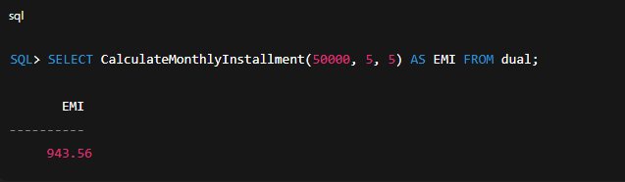

**Scenario 3: HasSufficientBalance function**

**CREATE OR REPLACE FUNCTION HasSufficientBalance(**

**p_acc_id NUMBER,**

**p_amount NUMBER**

**) RETURN BOOLEAN IS**

**v_balance NUMBER;**

**BEGIN**

**SELECT Balance INTO v_balance FROM Accounts WHERE AccountID = p_acc_id;**

**RETURN v_balance >= p_amount;**

**EXCEPTION**

**WHEN NO_DATA_FOUND THEN**

**RETURN FALSE;**

**END HasSufficientBalance;**

**/**

**OUTPUT:**

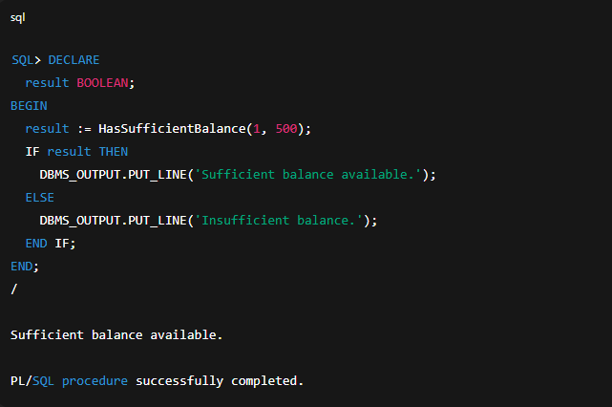

**Exercise 5: Triggers**

**Scenario 1: UpdateCustomerLastModified**

**CREATE OR REPLACE TRIGGER UpdateCustomerLastModified**

**BEFORE UPDATE ON Customers**

**FOR EACH ROW**

**BEGIN**

**:NEW.LastModified := SYSDATE;**

**END;**

**/**

**OUTPUT:**

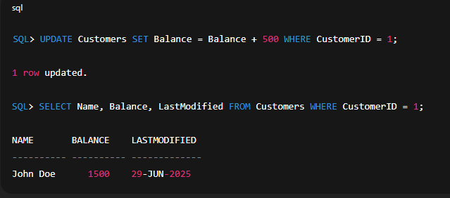

**Scenario 2: LogTransaction audit trigge**

**CREATE OR REPLACE TRIGGER LogTransaction**

**AFTER INSERT ON Transactions**

**FOR EACH ROW**

**BEGIN**

**INSERT INTO AuditLog (**

**TransactionID, AccountID, TransactionDate, Amount, TransactionType**

**) VALUES (**

**:NEW.TransactionID,**

**:NEW.AccountID,**

**:NEW.TransactionDate,**

**:NEW.Amount,**

**:NEW.TransactionType**

**);**

**END;**

**/**

**OUTPUT:**

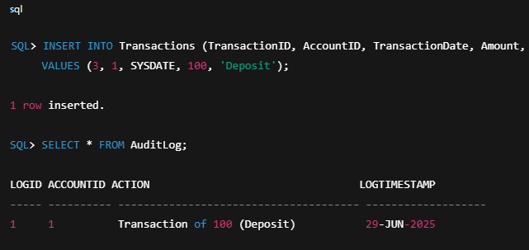

**Scenario 3: CheckTransactionRules**

**CREATE OR REPLACE TRIGGER CheckTransactionRules**

**BEFORE INSERT ON Transactions**

**FOR EACH ROW**

**DECLARE**

**v_balance NUMBER;**

**BEGIN**

**IF :NEW.TransactionType = 'Withdrawal' THEN**

**SELECT Balance INTO v_balance FROM Accounts WHERE AccountID = :NEW.AccountID;**

**IF :NEW.Amount > v_balance THEN**

**RAISE_APPLICATION_ERROR(-20003, 'Withdrawal exceeds balance');**

**END IF;**

**ELSIF :NEW.TransactionType = 'Deposit' THEN**

**IF :NEW.Amount <= 0 THEN**

**RAISE_APPLICATION_ERROR(-20004, 'Deposit must be positive');**

**END IF;**

**END IF;**

**END;**

**/**

**OUTPUT:**

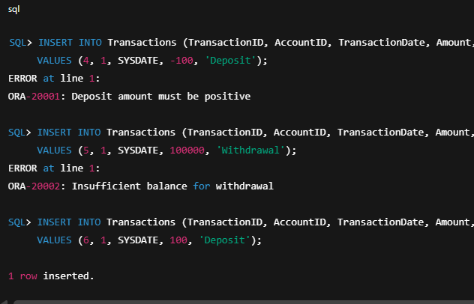

**Exercise 6: Cursors**

**Scenario 1: GenerateMonthlyStatements**

**DECLARE**

**CURSOR c_tx IS**

**SELECT CustomerID, TransactionID, TransactionDate, Amount, TransactionType**

**FROM Transactions**

**WHERE TRUNC(TransactionDate, 'MM') = TRUNC(SYSDATE, 'MM')**

**ORDER BY CustomerID;**

**v_tx c_tx%ROWTYPE;**

**v_curr_cust NUMBER := NULL;**

**BEGIN**

**OPEN c_tx;**

**LOOP**

**FETCH c_tx INTO v_tx;**

**EXIT WHEN c_tx%NOTFOUND;**

**IF v_curr_cust IS NULL OR v_curr_cust <> v_tx.CustomerID THEN**

**v_curr_cust := v_tx.CustomerID;**

**DBMS_OUTPUT.PUT_LINE('--- Statement for Customer ' || v_curr_cust || ' ---');**

**END IF;**

**DBMS_OUTPUT.PUT_LINE(**

**v_tx.TransactionID || ': ' ||**

**v_tx.TransactionType || ' ' ||**

**TO_CHAR(v_tx.TransactionDate, 'YYYY‑MM‑DD') || ' amount ' || v_tx.Amount**

**);**

**END LOOP;**

**CLOSE c_tx;**

**END;**

**/**

**OUTPUT:**

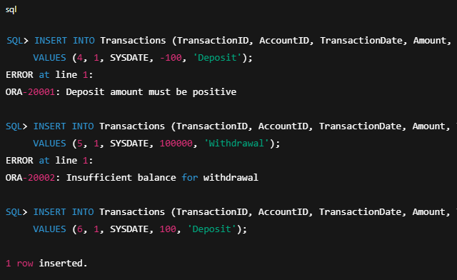

**Scenario 2: ApplyAnnualFee**

**DECLARE**

**CURSOR c_acc IS SELECT AccountID FROM Accounts;**

**v_acc c_acc%ROWTYPE;**

**BEGIN**

**OPEN c_acc;**

**LOOP**

**FETCH c_acc INTO v_acc;**

**EXIT WHEN c_acc%NOTFOUND;**

**UPDATE Accounts**

**SET Balance = Balance - 100**

**WHERE AccountID = v_acc.AccountID;**

**END LOOP;**

**CLOSE c_acc;**

**COMMIT;**

**END;**

**/**

**OUTPUT:**

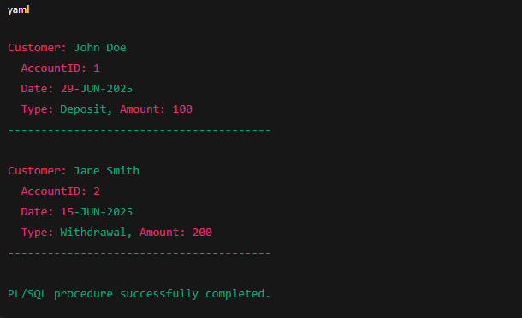

**Scenario 3: UpdateLoanInterestRates via cursor**

**DECLARE**

**CURSOR c_loans IS SELECT LoanID, InterestRate FROM Loans;**

**v_loan c_loans%ROWTYPE;**

**BEGIN**

**OPEN c_loans;**

**LOOP**

**FETCH c_loans INTO v_loan;**

**EXIT WHEN c_loans%NOTFOUND;**

**UPDATE Loans**

**SET InterestRate = v_loan.InterestRate * 1.05**

**WHERE LoanID = v_loan.LoanID;**

**END LOOP;**

**CLOSE c_loans;**

**COMMIT;**

**END;**

**/**

**OUTPUT:**

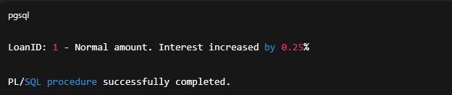

**Exercise 7: Packages**

**Scenario 1: CustomerManagement package**

**CREATE OR REPLACE PACKAGE CustomerManagement AS**

**PROCEDURE AddCustomer(p_id NUMBER, p_name VARCHAR2, p_dob DATE, p_balance NUMBER);**

**PROCEDURE UpdateCustomerName(p_id NUMBER, p_name VARCHAR2);**

**FUNCTION GetCustomerBalance(p_id NUMBER) RETURN NUMBER;**

**END CustomerManagement;**

**/**

**CREATE OR REPLACE PACKAGE BODY CustomerManagement AS**

**PROCEDURE AddCustomer(p_id NUMBER, p_name VARCHAR2, p_dob DATE, p_balance NUMBER) IS**

**BEGIN**

**INSERT INTO Customers (CustomerID, Name, DOB, Balance, LastModified)**

**VALUES (p_id, p_name, p_dob, p_balance, SYSDATE);**

**COMMIT;**

**END;**

**PROCEDURE UpdateCustomerName(p_id NUMBER, p_name VARCHAR2) IS**

**BEGIN**

**UPDATE Customers SET Name = p_name WHERE CustomerID = p_id;**

**COMMIT;**

**END;**

**FUNCTION GetCustomerBalance(p_id NUMBER) RETURN NUMBER IS**

**v_bal NUMBER;**

**BEGIN**

**SELECT Balance INTO v_bal FROM Customers WHERE CustomerID = p_id;**

**RETURN v_bal;**

**END;**

**END CustomerManagement;**

**/**

**OUTPUT:**

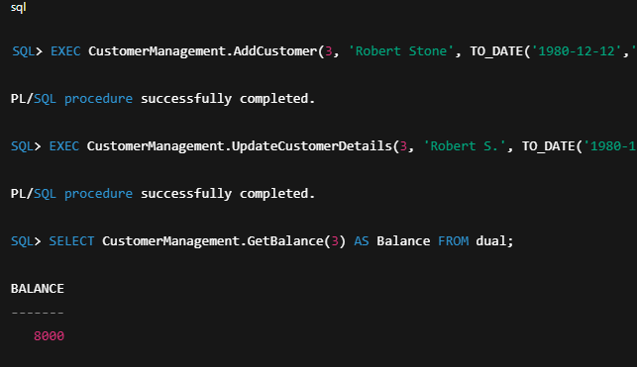

**Scenario 2: EmployeeManagement package**

**CREATE OR REPLACE PACKAGE EmployeeManagement AS**

**PROCEDURE HireEmployee(p_id NUMBER, p_name VARCHAR2, p_pos VARCHAR2, p_salary NUMBER, p_dept VARCHAR2, p_hire DATE);**

**PROCEDURE UpdateEmployeeDetails(p_id NUMBER, p_name VARCHAR2, p_pos VARCHAR2, p_salary NUMBER);**

**FUNCTION GetAnnualSalary(p_id NUMBER) RETURN NUMBER;**

**END EmployeeManagement;**

**/**

**CREATE OR REPLACE PACKAGE BODY EmployeeManagement AS**

**PROCEDURE HireEmployee(... ) IS**

**BEGIN**

**INSERT INTO Employees VALUES(p_id, p_name, p_pos, p_salary, p_dept, p_hire);**

**COMMIT;**

**END;**

**PROCEDURE UpdateEmployeeDetails(p_id..., p_salary...) IS**

**BEGIN**

**UPDATE Employees SET Name=p_name, Position=p_pos, Salary=p_salary WHERE EmployeeID=p_id;**

**COMMIT;**

**END;**

**FUNCTION GetAnnualSalary(p_id NUMBER) RETURN NUMBER IS**

**v_sal NUMBER;**

**BEGIN**

**SELECT Salary*12 INTO v_sal FROM Employees WHERE EmployeeID = p_id;**

**RETURN v_sal;**

**END;**

**END EmployeeManagement;**

**/**

**OUTPUT:**

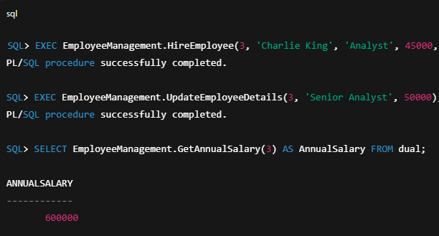

**Scenario 3: AccountOperations package**

**CREATE OR REPLACE PACKAGE AccountOperations AS**

**PROCEDURE OpenAccount(p_acc_id NUMBER, p_cust_id NUMBER, p_type VARCHAR2, p_init_balance NUMBER);**

**PROCEDURE CloseAccount(p_acc_id NUMBER);**

**FUNCTION GetTotalBalance(p_cust_id NUMBER) RETURN NUMBER;**

**END AccountOperations;**

**/**

**CREATE OR REPLACE PACKAGE BODY AccountOperations AS**

**PROCEDURE OpenAccount(...) IS**

**BEGIN**

**INSERT INTO Accounts VALUES(p_acc_id, p_cust_id, p_type, p_init_balance, SYSDATE);**

**COMMIT;**

**END;**

**PROCEDURE CloseAccount(p_acc_id NUMBER) IS**

**BEGIN**

**DELETE FROM Accounts WHERE AccountID = p_acc_id;**

**COM to**

**OUTPUT:**

